Path Planning – Using rosbag files to create a polygon for coverage map input

Run two perimeter runs; Save both rosbag files into .csv files with the time delta, time stamp and lat/lon
  - 'collins_dr_62_A_from_rosbag_run1'
  - 'collins_dr_62_A_from_rosbag_run2'

- I then manually merged the .csv data in excel to get the points only for the desired cutting area and placed that data in a different .csv file (e.g. Site_04.csv)
- I used Plotjuggler to review the points

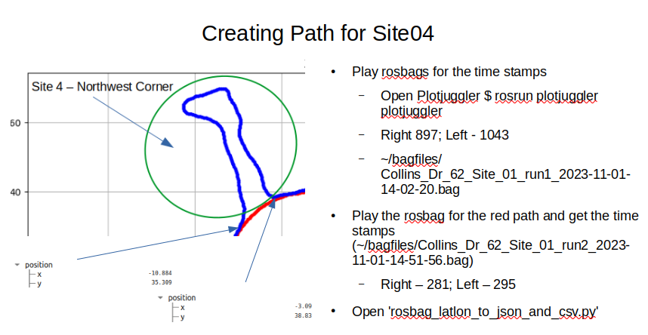

While reviewing Plotjuggler I noted the /odom topic x, y points so I could cut and paste the correct records into a ‘Site_04.csv’ file.
Update the location db (~project_notes/paths/paths_locations.csv)
- Number of rings – how do I decide
- Start x and y – how do I decide – I think this is where the polygon rings start. I need to print the polygons and decide a good point to break up the polygon.
I need to get the sequence of the points aligned in clockwise or counter-clockwise fashion.

I used ‘/path_helper_to_visualize_first_xy_point.py’ to plot the original list
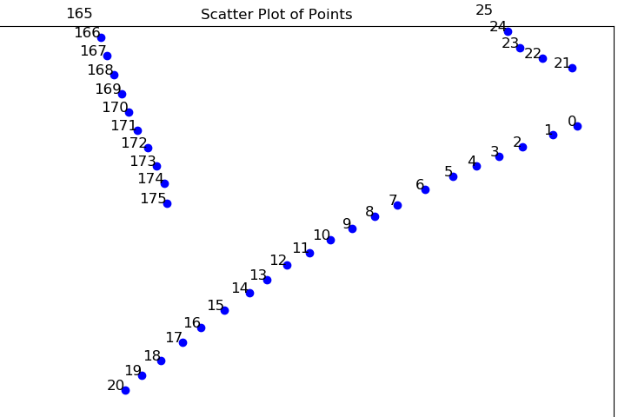
This shows me I want to reverse the order of 0-20.
To do that I need to add a column to the x, y .csv file and re-sort 0-20, then delete the sequence column and re-run

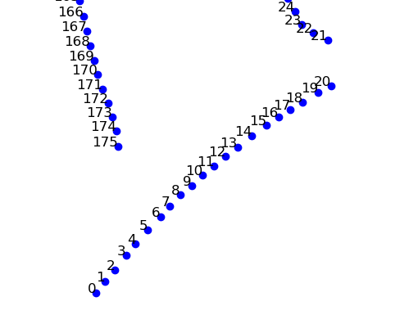

I then selected the starting point, updated and ran path_create_inner_ring_path_v5.py which reads .csv file; Calculates the inner rings an offset distance inside the polygon based on the function ‘read_points_from_csv’ which loads the X, Y coordinates from columns. It also calculates the angle between the points, but this is premature now since it is finalized in the ll2xy program.

